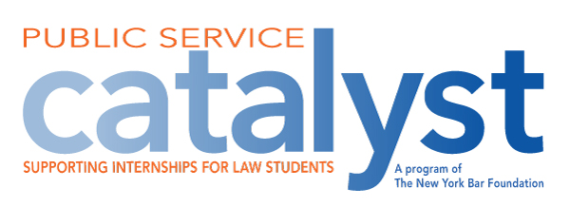

**Application Form**

Please provide the following information:

**Name:**

**Mailing Address:**

**Phone/Email:**

**If position obtained at time of application:**

**Name of Summer Employer:**

***For purposes of the Program, a public sector employer means a New York State prosecutor, a public or not-for-profit agency which provides criminal defense or civil legal services for the indigent and/or representation in juvenile justice or child protective proceedings in New York State courts and the New York State Unified Court System.***

**Name, Title, Address, Email and Phone Number for Employer Contact:**

**Number of Weeks of Internship/Number of Hours per week:**

**Please answer the following questions on a separate sheet (not longer than two pages):**

1. **How will obtaining the Catalyst Public Service Fellowship will enable you accept an otherwise unpaid**

**public service legal summer internship?**

1. **Why do you want to potentially pursue a public service career?**

**Applicant’s Signature**

**Date:**